

**OUR CULTURE, HERITAGE AND VALUES**

**ANTALYA**

**Story**

During the Hellenistic period, king of Pergamon II. Attalus (159–138 BC) tells his soldiers: “Go and find me heaven on earth.” I liked the place that his soldiers showed. Given the strategic importance of the region, Attalos built a port city here, and the city was named "Athaleia" after its founder **Attalos. Atelea** means "Land of Attalos".

Antalya and its surrounding areas have a heritage of two lifestyles that have existed for centuries. When the Turks first came here, they immediately adapted to the established order; They founded villages, towns and cities. Part of the population continued to wander, as before the arrival of the Turks in Anatolia.

They raised animals such as camels and sheep, and made a living by bartering or selling the products they produced for those of settled people. They produced meat, milk and butter, and wove tents and carpets from natural madder. There were even people who planted grain and vegetables in narrow wintering areas. There were even large nomadic groups (tribes, clans) that trained horses for the Ottoman army.

**Natural beauty**

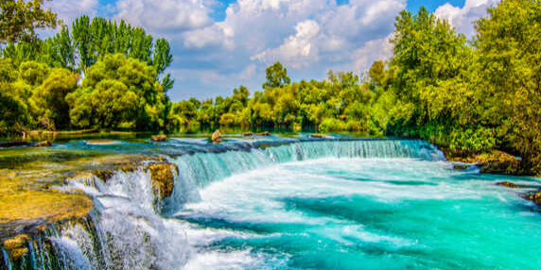

**Manavgat Waterfall:** Located in the Manavgat district of Antalya. Certain stretches of the river offer various outdoor sports such as rafting and canoeing, allowing you to experience waterfall adventures with magnificent natural views.

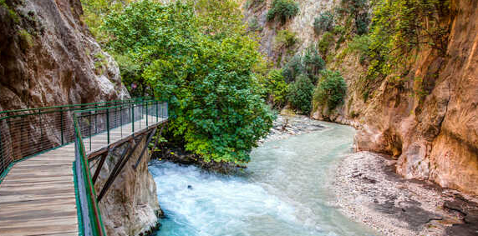**Saklikent Canyon:** Located between the borders of Antalya and Fethiye, Saklikent Canyon has a total length of 18 kilometers. If you want to plan a trip close to nature, the Saklikent Canyon also has forested areas formed by red pine, cedar and larch, where you can have a very pleasant time.

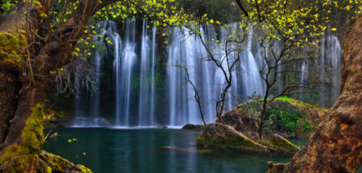

**Kursunlu Waterfall Natural Park:** located in the Aksu district of Antalya. Kurşunlu Waterfall, consisting of seven ponds, falls from a height of approximately 20 meters. An integral part of Antalya holidays due to its refreshing effect and views, the waterfall was opened to visitors as a nature park in 1991.

.

**.**

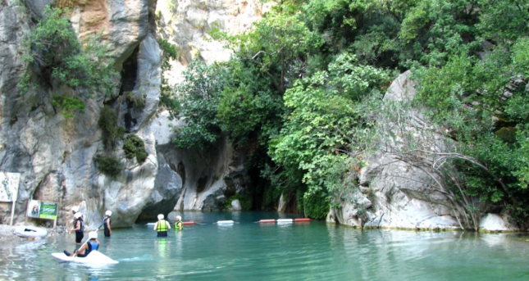 **Goynuk Canyon:** located in the Kemer area of ​​Antalya. It is located on the Lycian Way, which is ranked by various sources as one of the top ten long-distance walking routes in the world. The pond with lush green water makes for an impressive view.

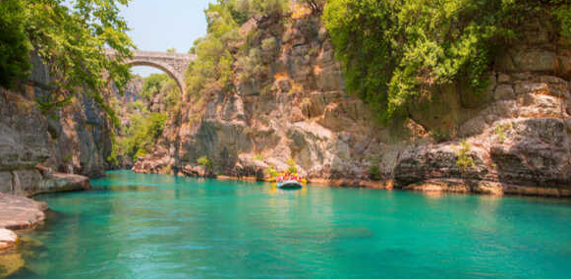

**Köprülü Canyon National Park:** Located in the Bozyaka area of ​​Manavgat district, Köprülü Canyon National Park is 25 km long. Köprülü Canyon, which amazes visitors with its natural beauty, is the most popular rafting destination in Turkey. Rafting is a fun and exciting river sport that is performed on rivers with strong currents in boats called rafts.

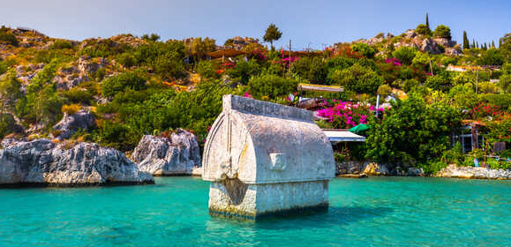 **Kekova Island:** Located in Demre district of Antalya. There are no buildings on the island of Kekova where you can enjoy the sea and organize historical trips during your holiday in the Mediterranean. Around the island there are also sunken ancient cities that offer a very impressive visual spectacle with turquoise seas, entry is prohibited.

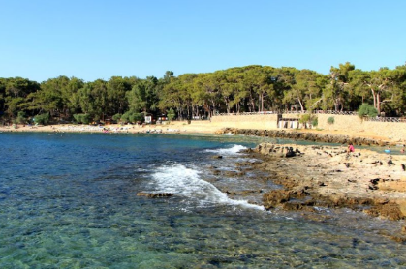**Incekum Nature Park:** Located in the Alanya region of Antalya. It stands out among the most important natural beauties of Antalya. Situated in a unique location where the green of the forests meets the blue of the Mediterranean, the park is the ideal place for a relaxing time away from the bustle of the city.

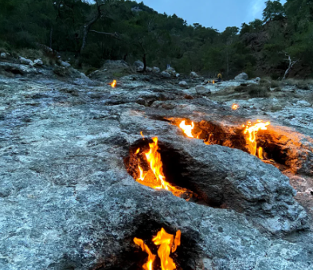

**Cirali Yanartas:** It is located in Kemer district of Antalya. Situated at the foot of Chataldag, one of the natural beauties of Kemer, Cirali Yanartas has very impressive features. The fire burns 24 hours a day in an area where methane gas can be seen constantly burning among the rocks at the summit.

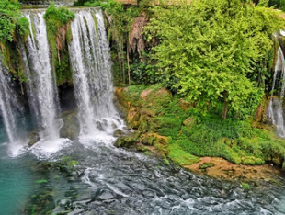**Duden Waterfall:** Duden Waterfall is one of the most visited tourist destinations in Antalya due to its breathtaking natural beauty. According to rumors in 334 BC. e., the commander Alexander the Great watered his horses here, intending to conquer the Pamphylia region. There are two waterfalls: Lower and Upper Duden.

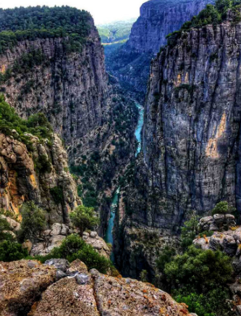

**Tazy Canyon:** This is a canyon located in Manavgat district of Antalya province. The Tazy Canyon, located within the boundaries of the Koprulu Canyon National Park, was formed by the Kepruchay stream, which erodes the valley. It is assumed that the formation of the canyon dates back to the Ice Age. It was formed by carving out the interior of limestone rocks in non-limestone regions as ice masses separated from each other, melted and released into the valleys, creating erosion with enormous energy. The length of the canyon is 4 km.

**Historical places**

Kaleici, Antalya Old Houses, Yivli Minaret, Şehzade Korkut Mosque, Karatay Madrasah, Perge Ancient City, Karain Cave, Hadrian's Gate, Phaselis Ancient City, Phaselis, Aspendos Theater, Ancient

Xanthos Town, Silion Ancient Town, Alanya Castle, Myra Ancient Town, It has many cultural heritages such as Temple of Apollo and Olympos Ancient Town.

**Agriculture and Livestock**

Various agricultural products grow on the fertile lands of the Antalya region. Agricultural products mainly include wheat, barley and oats. In addition, cotton, sesame, onions, peanuts, chickpeas and vegetables are grown on 35 thousand hectares. This is our most advanced province in greenhouse growing. Tomatoes, peppers, beans, eggplants, cucumbers, melons and watermelons are grown in greenhouses covering an area of ​​32 thousand hectares. It is sold domestically and internationally. Antalya is very developed in fruit growing. The province that produces the most

bananas and oranges, is Antalya. In addition, apples, pears, plums, quinces, peaches, apricots, grapes, oleaster, carob, cranberries and other fruits are grown. Tangerines, lemons and grapefruits are Antalya's main source of income. In addition to citrus production, olive cultivation is also highly developed. The Antalya region has its own climatic characteristics, rich vegetation and a wealth of wildlife. Deer, fox, marten, squirrel, fallow deer, wild goat, jackal, hyena, wolf, bear, partridge, quail, dove, wild pigeon, woodcock, francolin, blackbird, oriole and crane constitute the major wildlife species of the province.

**Transport**

If desired, Ancient Side can be reached on foot along the coastal road or by using public transport at the stop near our facility. In addition, to see other natural and cultural heritages of Antalya, you can go to the center of Manavgat, and from there you can go anywhere using the municipality's public transport.

**Markets**

Markets are held every day of the week in the center of Manavgat, where locals shop. This market sells both textiles and food products specific to the region. The markets in the center can be reached by public transport from stops located near the site. Once in the city center, you can stroll to the Monday and Thursday markets. For the markets on Wednesdays, Saturdays and Sundays you can also use the municipality's public transport.

**Atatürk**

Our great leader Mustafa Kemal Atatürk is the founder and first president of the Republic of Turkey.

He was born in Thessaloniki in 1881. His mother is Zubeyde Hanım and his father is Ali Riza Effendi.

After military training, he went to Samsun on May 19, 1919 and began the national struggle when his homeland began to be occupied. With the opening of the Turkish Grand National Assembly, he was elected chairman of the assembly and government. Then, with the victory in the Sakarya War, he received the title of Ghazi and Marshal. He became the first President of the Turkish Republic with the proclamation of the Republic in 1923. He physically died on November 10, 1938.

National and religious values

**Our National**

Anthem, which is performed with a minute of silence during national holidays that are celebrated with enthusiasm, such as State Sovereignty and Children's Day on April 23, Ataturk Memorial Day on May 19, Youth and Sports Day, Victory Day on August 30 and Republic Day on October 29, is also one of our national values. Our national anthem was written by Mehmet Akif Ersoy and adopted by the Turkish Grand National Assembly on March 12, 1921. It was later written by Osman Zeki Jungor. Eid al-Fitr and Eid al-Adha are among the religious values.

**Traditional crafts and crafts in Antalya**

Antalya, which has been a cultural basin throughout its history and retains this feature today, also attracts attention with its variety of traditional crafts. As a result of the field research conducted on different dates in our city, some of the identified crafts can be listed as follows;

• Construction of wooden boats

• Coppersmithing

• Cutlery

• Instrumentation

• Making bells

• Production of dowry chests

• Knitting socks

• Blacksmith craft

• Glass Figla glass production

• Gilamik weaving

• Carpet weaving

• Silk weaving

• Tinsmith

• Khashoggi

• Carpet weaving

• Girth (charpana) weaving

• Handicrafts Knitting

• Pumpkin processing

• Quilting

**Local folk dances**

The folk dances of the Antalya region have a regional feature called "Tek Folklore". Yoruk influence predominates in the region's folk dances as well as music. Dances of the region; It consists of dances performed by dancers without holding each other, such as Mengi, Samakh, Teke, Kashik and Zeybek dances. In the areas east of Antalya, Konya Spoon Air, Bosphorus Air, Serenler Zeybegi, Anamur Rhodes, Yogurt Silifke, Algerian Air play. These games can be played individually or in groups.

**Local dishes**

The Yoruk's diet consists of livestock products and wheat. Although the coast produces a small amount of fresh vegetables, the inland regions are dominated by wheat and dried vegetables. In Antalya's tourist hotels and restaurants you can find all the cuisines of the world. Local dishes typical of this region: sak roast, tandoori skewers, kölle (boiled wheat, beans, chickpeas and kidney beans), tomato tsivesi, khibesh, arapashi.

**Holidays and festivals**

Festivals and celebrations are held in Antalya at different times. These festivals are usually summer festivals in the Antalya highlands (eg Feslikan Plateau Festival, Söbüçe Plateau Festival, Alanya Festivals). Additionally, people living in the Alevi-Bektashi-Turkmen culture in the Elmaly region also organize festivals (such as the Abdal Musa festival). Festivals are organized both locally, nationally and internationally in Antalya. The largest national festival is the Antalya Television Awards, which began to be held in 2010.

The Antalya Golden Orange Film Festival is held internationally every year in October. Additionally, the Antalya International Sand Sculpture Festival is one of the largest traditional sand sculpture events in Turkey and the largest in the world.